**Weekly report 7**

**Group 14: Learners.**

**Heart Disease Prediction.**

**01-04-23**

Members:

1. Varun Parekh - AU2040011
2. Vanshit Shah - AU2040098
3. Madhvendra Jhala - AU2040162
4. Ushmay Patel - AU2040253

We tried to work on understanding different parameter tunings and also the dataset details that we lacked in our mid-sem presentation. XgBoost is known to be the best predictor in case of Heart diseases and so we are now thinking of finalizing it and working more on its accuracy.

As mentioned in the previous report, during this week we tried to implement the XG-Boost algorithm. We were able to achieve an accuracy of 78.69%. And further, we would try to improve upon the existing algorithm to make the predictions more accurate.

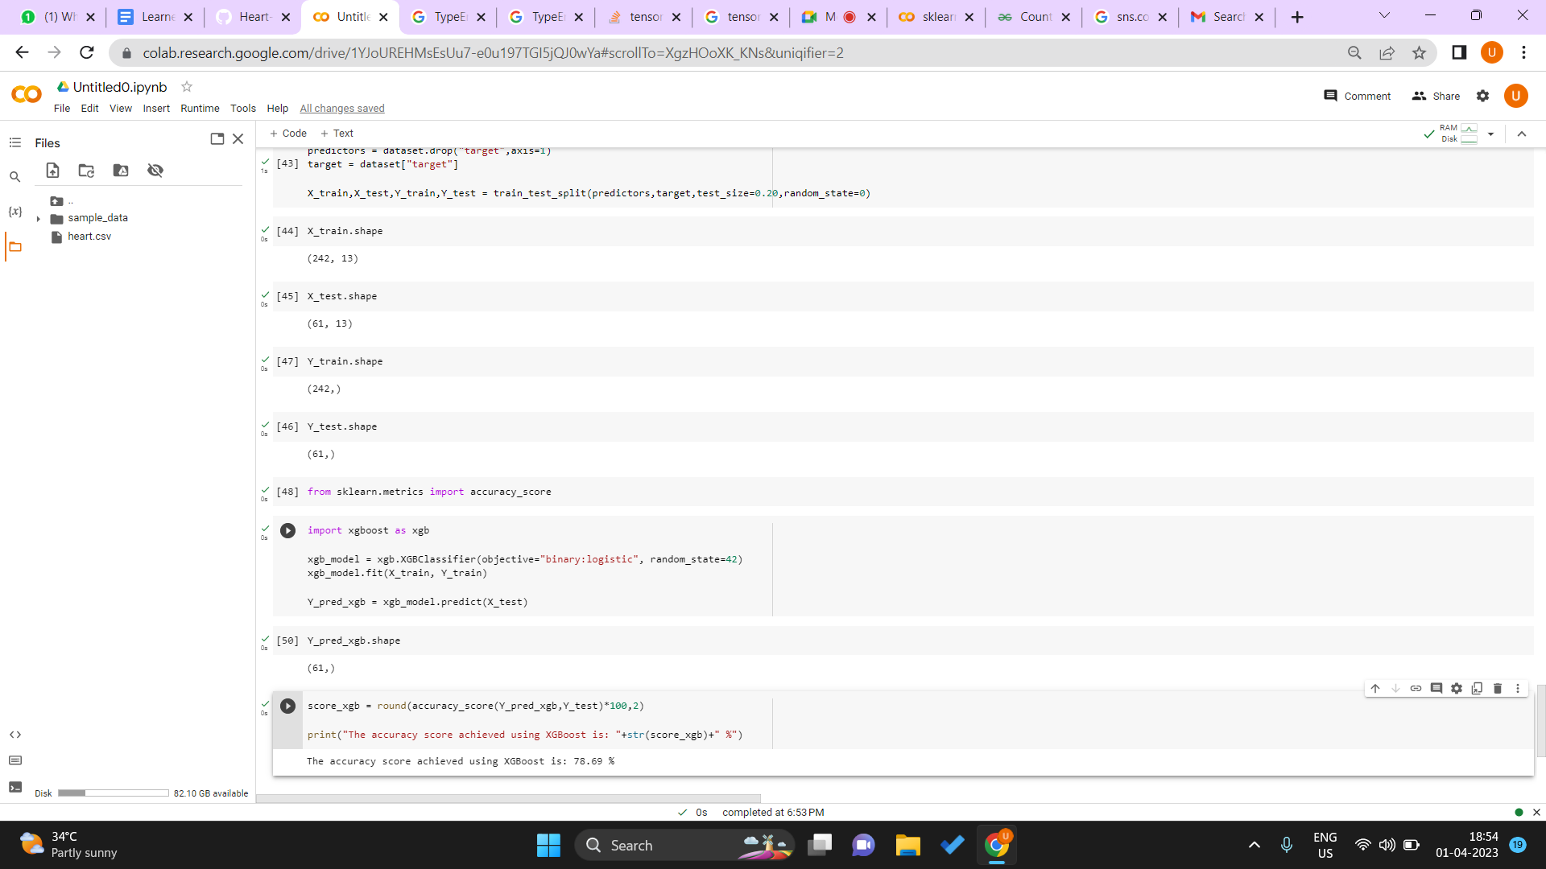

Google colab link: <https://colab.research.google.com/drive/1YJoUREHMsEsUu7-e0u197TGI5jQJ0wYa#scrollTo=XgzHOoXK_KNs&uniqifier=2>

We also tried to plot the parameters but were facing error with plotting them separately and hence would also try to figure out how we could resolve the error.

